20.11.2008
Name :
Number :
CEM 121 DIGITAL LOGIC
Quiz 3
(10) |  | Draw the output waveforms ( X , Y and Q ) for the following logic diagram.  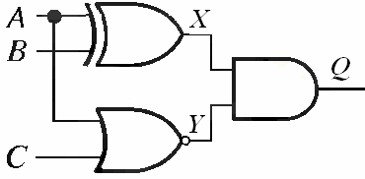  A  B  C  Y  Q  X
(10) |  | Implement the F function using a 3:8 decoder with a OR gate.  F(A,B,C)=ABC + A’BC + AC’

